Top tips for comprehension
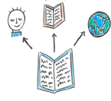

Activate and Use Background Knowledge

What does this book remind you of?

Use things you already know to help you understand.

Generate and Ask Questions and Predict

Ask yourself questions as you read.

Why did they do that? …say that? …what’s happening here? …what might happen next?

Notice new and important words

Is there a word that you can’t read, or that you don’t understand?

Don’t skip it; find out what it is.

Some words or phrases are really important to help you understand your reading.

Can you spot them?

Make Inferences

Can you find clues that the author has left for you? The author doesn’t tell you everything – you have to work some things out.

Combine what the author says with your background knowledge to understand your reading.

Visualize

Can you make pictures in your head as you read?

This will help you understand the story and remember it.
Monitor and fix it.

Can you notice when your reading doesn’t make sense?
Try to fix it.
You can re-read, read ahead, look up words in a dictionary or glossary, or ask someone for help.
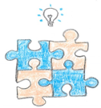

Summarize

Can you tell someone the main parts of what you’ve read in your own words?

If you can’t, you will need to read it again and maybe write down the characters names, the place the story happens and the main event to help you remember what it is about.

Anna Welsh 2020

