Race Across the World
Task 4
Throughout your journey from Los Angeles to Buenos Aires, you might travel through Peru and stop at the world-famous Machu Picchu. The Inca ruins of Machu Picchu is one of the most famous archaeological sites in the world.
It’s no wonder why Machu Picchu, which is located high in the slopes of the Andes, is a much loved UNESCO heritage site. You can read more about this incredible site in the fact file.
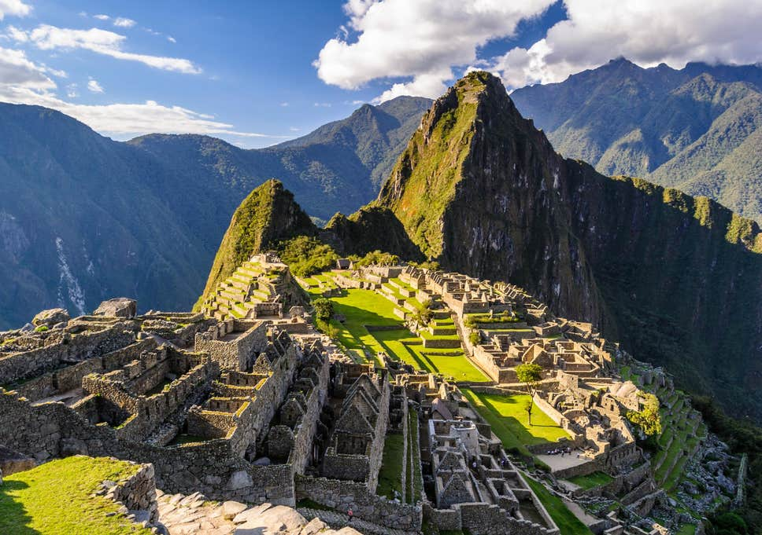

Your task is to write a postcard to a family member or friend from Machu Picchu.

You need to think about the following questions.
- How has your journey been so far?
- Where have you been?
- What have you seen?
- Who have you met?
- What has been your favourite place or moment so far?
- What are you looking forward to on the next part of your journey?

Now, design the front of your postcard.

