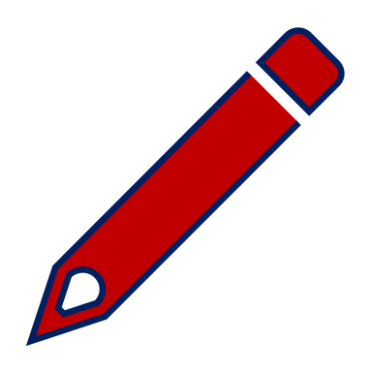 Non-fiction Challenge 2 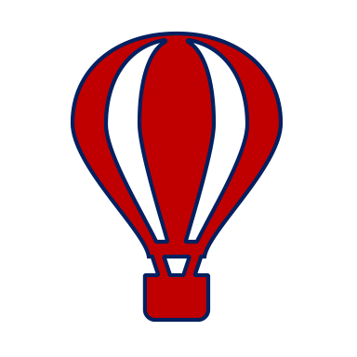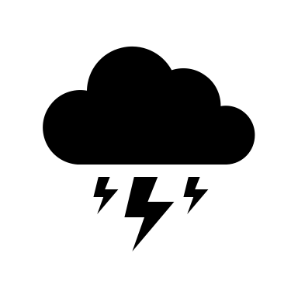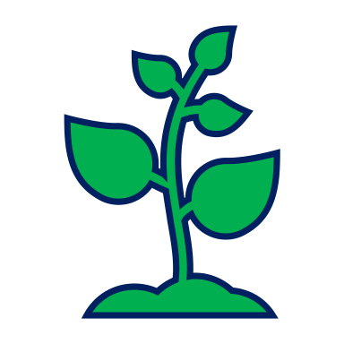

Read a paragraph or a page of a non-fiction book, magazine or website.

(It is best to read it twice.)

Fold a piece of paper in half.

Unfold it and you should have two rectangles.

Draw a line across the paper near the top.

On the line at the top of the first rectangle write one of the things you were reading about – maybe spiders.

On the line at the top of the second rectangle write another thing you were reading about - maybe insects.
One thing I read about | Another thing I read about

Think about the first thing you chose. In the first rectangle write down something you found out about it – maybe the number of legs a spider has got.

Now think about the second thing you chose. In the second rectangle compare it to the first thing (is it the same or different) – e.g. how many legs has an insect got?

Compare four more things about them – number of body parts, habitat, food, colour …

You could compare two types of weather, vehicles, plants, countries … whatever you are reading about.

