Race Across the World Challenge
Task 6
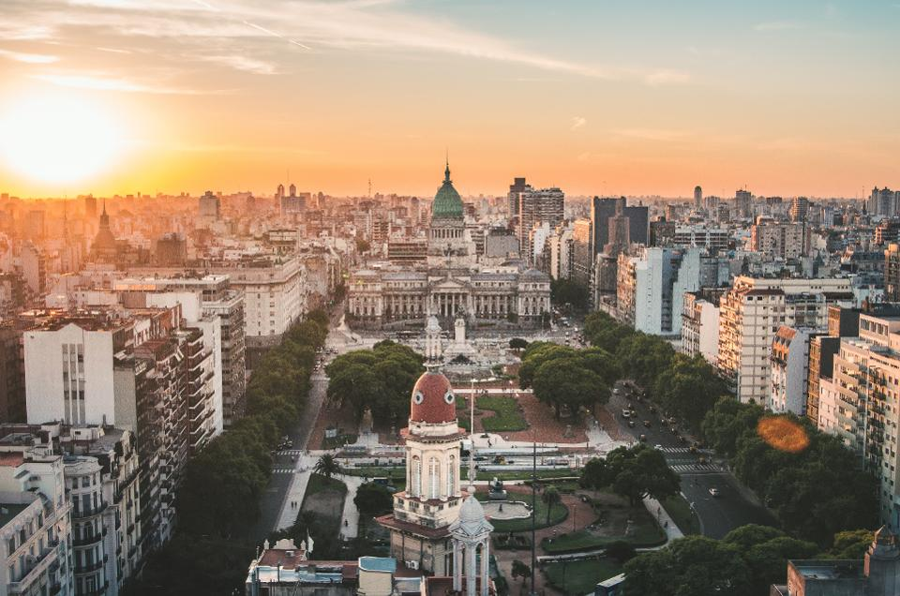
Congratulations! You have finally arrive in the Argentinian capital of Buenos Aires!

Now you are here you will want to enjoy exploring the city! Your first task is to research what the city has to offer! The attached fact file and links below will help you research the city.
https://www.kids-world-travel-guide.com/argentina-facts.html
https://www.daytours4u.com/en/travel-guide/bsas4u/things-to-do-with-kids-in-buenos-aires/
https://www.viator.com/en-GB/Buenos-Aires/d901-ttd/3
Once you have done that, your second task is to create an itinerary for your day exploring Buenos Aires.
You will need to plan: two morning activities; a place to have lunch and afternoon activity. You can also plan an evening dinner or activity if you wish.
Example
Morning | Visit San Telmo and explore the local market
 | Photography tour of San Isidro
Lunchtime | Eat empanadas at Casa Muamor
Afternoon | Rent a pedal boat and explore Parque 3 de Febrero
Evening | Steak dinner and tango show

