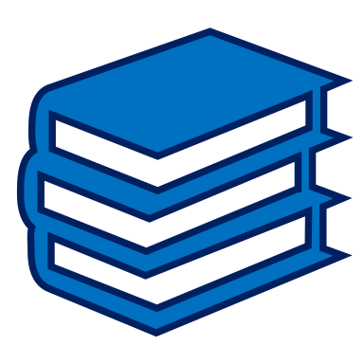 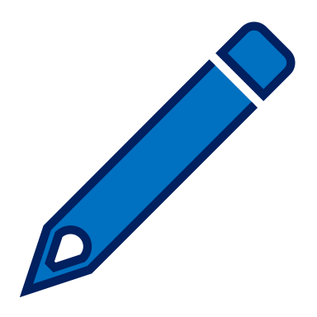 Non-fiction Challenge 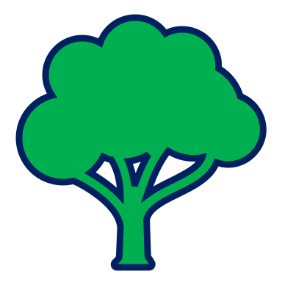

Fold a piece of paper in half and then in half again.

Unfold it and you should have four rectangles (like in the diagram.)

In the first rectangle write and draw a picture of the subject that you are going to read about e.g. the plant, animal, sport etc.

In the second box write two or three things that you already know about this subject.

Now read a paragraph or a page of a non-fiction book, magazine or website.

(It is best to read it twice.)

In the third box and fourth box write two new things that you have learnt from what you read.
- Subject. | - Two things I already know.
- One thing I learnt. | - One more thing I learnt.

- Try this challenge with another page or article. You could do two new things you’ve learnt in boxes 3 and 4.

