Race Across the World Challenge
Task 5
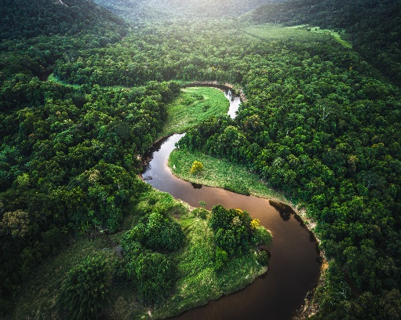
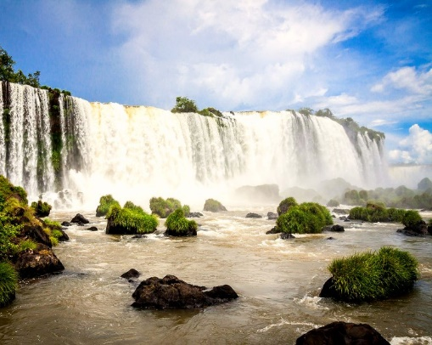
Throughout your journey from Los Angeles to Buenos Aires, you will travel through many amazing places and see some world-famous sights.
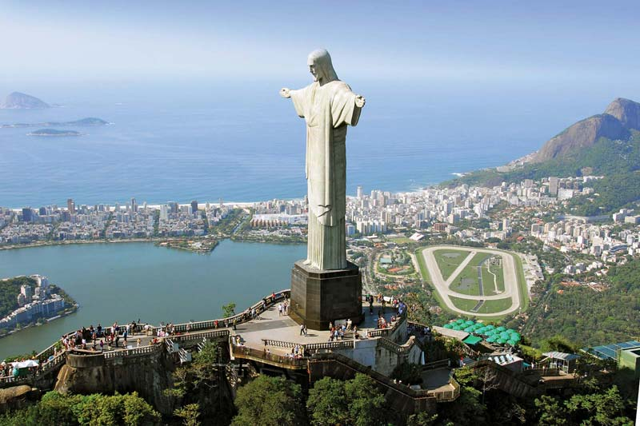
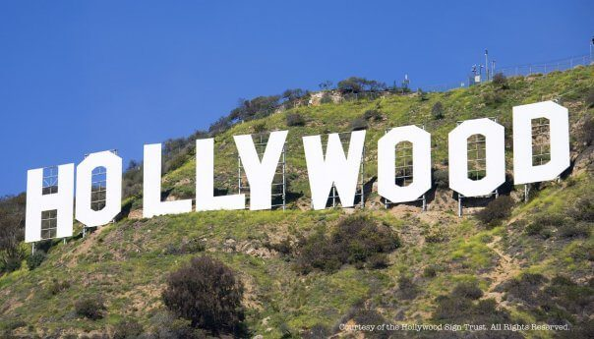
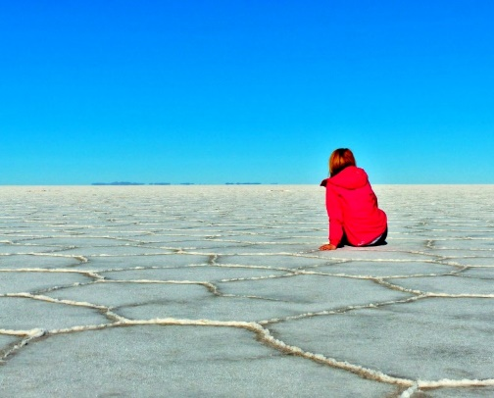
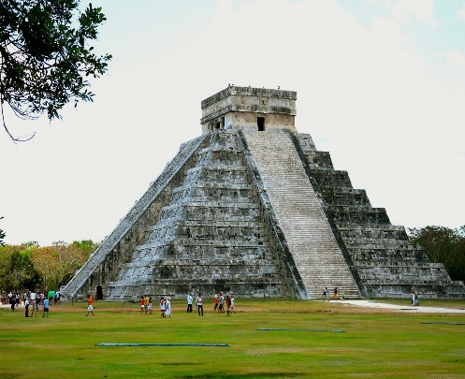
1st row (left to right): Chichen Itza, Bolivian Salt Flats and Iguazu Falls
2nd row (left to right): Hollywood sign, Christ the Redeemer and Amazon River

Your task is to draw some selfies of you visiting some amazing sights on your journey.
Use the link below to get some handy tips on how to draw a self-portrait for your selfie.
Make sure you post your selfie pictures on the class blog for everyone to enjoy!
https://www.bbc.co.uk/teach/class-clips-video/art-and-design-draw-self-portrait/z6ytscw

