Race Across the World Challenge
Task 7
Now you know more about the Argentinian capital of Buenos Aires, you are going to put your newly acquired knowledge to use! Your task is to create a tour, class or activity that people could book when they visit Buenos Aires. Will you take visitors on a food tour to sample local dishes? How about exploring the city’s famous sights on bikes? Perhaps a dance class where visitors can learn traditional dances? It’s your choice!
https://www.viator.com/en-GB/Buenos-Aires/d901-ttd/3
You might want to use the link to explore the tours people already offer in Buenos Aires.
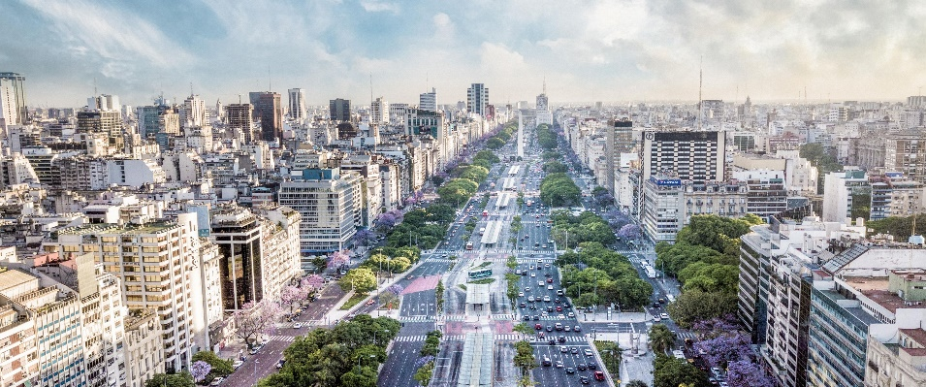

You will need to think about:
- What type of tour, class or activity would you like to run?
- What unique experience will you offer? What will you see or do?
- Who is your activity aimed at?
- How much will you charge customers?
- Do you need transport? What type of transport will it be?
- Is food included?
- Is there free time for visitors to explore themselves?
- Is there someone leading the activity? Who is it?
- How long will your activity last?
- How often will the activity run? Is there a choice of times?

Once you have planned your tour, class or activity, you will need to advertise it. You can create a poster or a leaflet to advertise your new venture. Remember that it needs to be clear, eye-catching and persuasive!

When you have finished, publish your work on the class blog. We would love to see your work!

