Introducing

Holymead Primary School Governors.

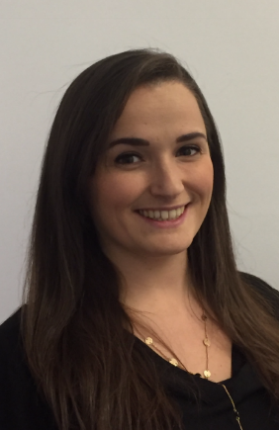

**Jessica Coggins – Chair of governors**

I became a co-opted governor in October 2017 and I am currently the Chair of the Governors, a member of the Health, Safety and Wellbeing Committee and the link governor for writing and EYFS. I am passionate about equality and diversity, alongside the accessibility and provision of quality education. Employed by the University of the West of England (UWE) as a Research Associate, I am currently working on two projects exploring treatments for Complex Regional Pain Syndrome.

**Kate Slatcher – Head Teacher**

I have been a governor at Holymead since I became head of the infant school in January 2005. During that time, I have worked closely with governors to merge the previously separate schools into one single primary school providing a good all through education for pupils from 4-11 years. It is a pleasure to serve on a board of dedicated governors who provide support and challenge to help maintain the great work that is done at Holymead.

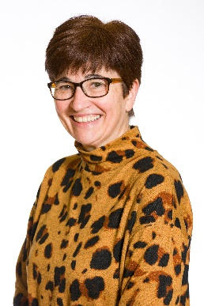

**Ruth Clacey-Roberts – Vice Chair of governors**

I have been a parent governor since May 2018 and I have two children currently attending the school. I am the Vice-Chair, Chair of the Health, Safety and Wellbeing Committee and the lead governor for Health, safety and Wellbeing. I currently work as an Employment Relations Consultant, having spent the previous 12 years working as an employment solicitor.

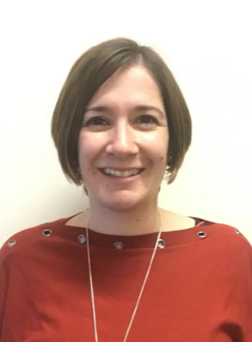

**Amy Callaway**

I have recently become a co-opted governor and sit on the Finance and Staffing committee. With a keen interest in employment law and employee engagement, I am a Human Resources Manager within a Financial Services organisation. I am passionate about quality education and providing the right opportunities, skills and resources for all. With over ten year’s experience I have also been a children's sports coach in both a club and school environment.



**Jo Head**

I have taught at Holymead Primary School since 2005 across both the Foundation Stage and Key Stage 1. I am now the Deputy Head of the KS1 site.

I love teaching at Holymead and enjoy being part of the governing body contributing the running of the school in the interest of our community.

I am a staff governor and sit on the Curriculum Standards and Inclusion committee.

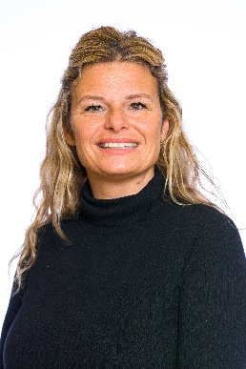

**Robert Ryan**

I am a Parent Governor who joined in February 2019 and I am currently the Governor for SEND and Children in Care. Originally from London, I currently have two children in the school (one on the infants site and one on the juniors) and have lived in Brislington for over 10 years. As a professional I work in a recruitment team for a large multi-national services company, with a particular focus on external marketing and communications



**Phil Wright**

I have been a governor at Holymead since 2009. Firstly at the juniors and then playing a role to bring that school together with the infants to create Holymead Primary. I have taken many lead roles including being Chair and vice-chair of governors and chairing the Finance Committee. I am currently a co-opted governor, but do have one child still at the school.

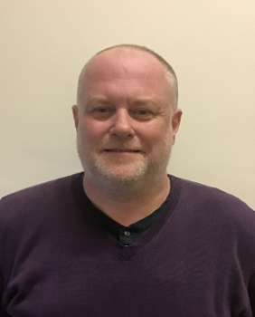

**Judith Buckley**

I am the Business Manager at Holymead Primary and have worked at the school for nearly 30 years. I have also been a governor for many years. I sit on the Finance and Staffing Committee, as well as the Health, Safety and Wellbeing Committee. I provide the governors with information about the budget, quotes for larger purchases, walk round the buildings prioritising maintenance and upgrading work to be done throughout the year, as well as looking at the various policies that are in place to make the school a safe, well-kept and pleasant place to work for staff, children and parents alike.

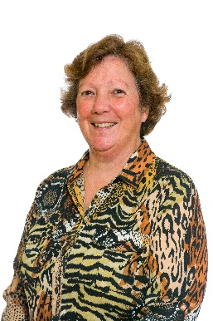

**Dean Smart**

I am the school’s Local Authority Governor, nominated by the City Council, and have a long association with the school as ‘community representative’, serving in various roles. I currently chair the Finance and Staffing Committee and attend the Health, Safety and Wellbeing Committee. I have a professional background in education and research supervision, and work at UWE. I have experience of being a trustee of charities and a non-profit organisation, and of INGO service.

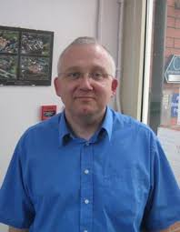

**Deb Miles**

I am a new Parent Governor who joined this academic year and sit on the Curriculum, Standards and Inclusion Committee. I have two children at Holymead in year 2 and year 5 and have lived in Brislington for over 9 years. I have worked in Arts Education for the past 15 years and currently am a Performing Arts Lecturer at Bath College.



**Pete Tayler-Hunt**

I have been a co-opted governor at Holymead since December 2020 and I sit on the Curriculum, Standards and Inclusion committee (CSI). I have a background in education having served as an education and training specialist in the British Army before moving to work in postgraduate medical education as an educationalist and lecturer. I’m employed as a business and education manager in Health Education England.

