High frequency spellings for Year 1 End of term 1
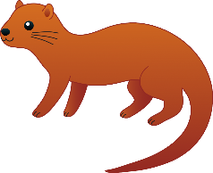

The words highlighted below are the high frequency words your child is now ready to learn to spell.
Please take a few minutes 3 times each week to learn these spellings. We will be reviewing your child’s progress at the end of term 2.
Ideas on how to practise these spellings at home.
- Look at the word, say it, cover up the word, write it and check you have spelt the word correctly (see the reverse).
- Somebody calls out the word and your child can write it down.
Phase 2
the | to | I | no | go | into
a | is | his | of | has | in
at | it | if | off | on | can
dad | had | back | and | get | big
him | not | got | up | mum | but
an | as

Phase 3
he | she | we | me | be | was
you | they | all | are | my | her
will | that | this | then | them | with
see | for | now | down | look | too

Phase 4
said | have | like | so | do | some
come | were | there | little | one | when
out | what | went | it’s | from | children
just | help

Phase 5
oh | their | people | Mr | Mrs | looked
called | asked | could | by | house | your
here | put | about | I’m | day | made
came | make | time | saw | very | don’t
old

