Race Across the World
Task 1
Travelling to countries on the other side of the world is easier than ever in the 21st century thanks to air travel. Now imagine if you couldn’t travel by air. Could you do it? How would you do it?
Your task is to explore how you could travel across the globe but without stepping foot on a single plane. You could use buses, trains or boats!
Example
If you wanted to travel from Paris (France) to Tallinn (Estonia) without getting on a plane, there are many routes you could take.
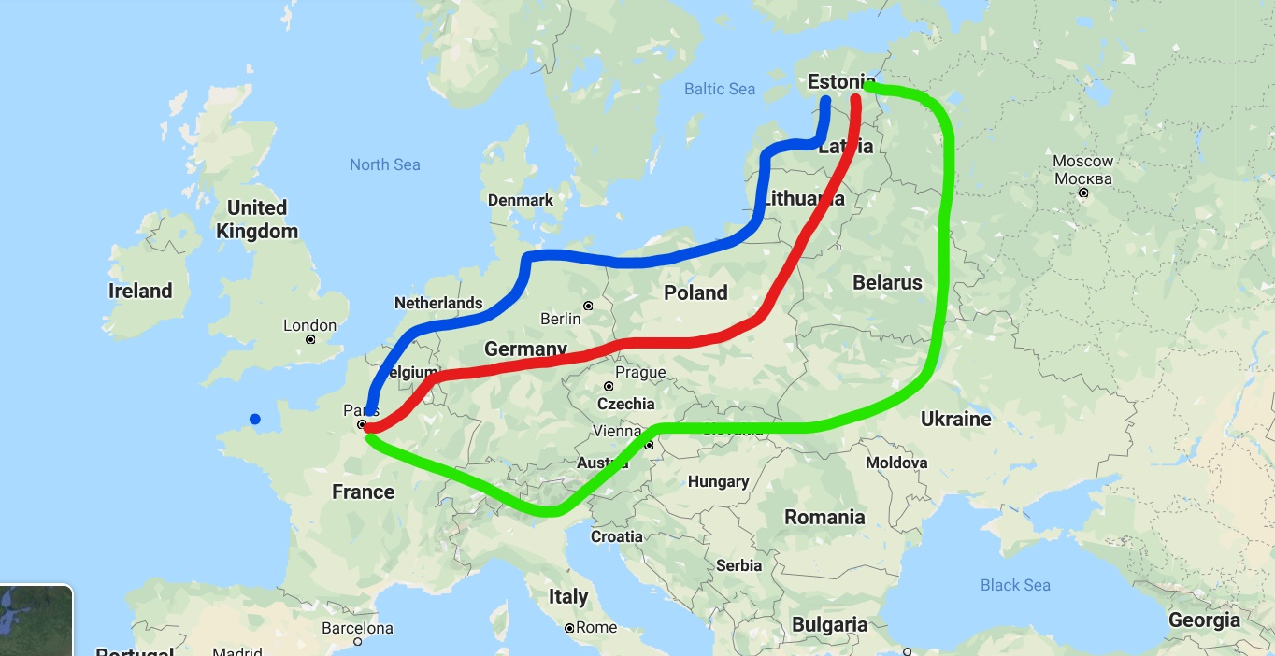
Blue Route: France, Belgium, Netherlands, Germany, Poland, Kaliningrad, Lithuania, Latvia and Estonia.
Red Route: France, Belgium, Luxembourg, Germany, Poland, Lithuania, Latvia and Estonia.
Green Route: France, Switzerland, Italy, Austria, Czech Republic, Slovakia, Ukraine, Belarus, Russia and Estonia.
Your task
How would you travel from Los Angeles (USA) to Buenos Aires (Argentina) without using a plane? Plan a three different routes like the example above. Use a map (e.g. Google maps) or an atlas to help you plan your journeys.
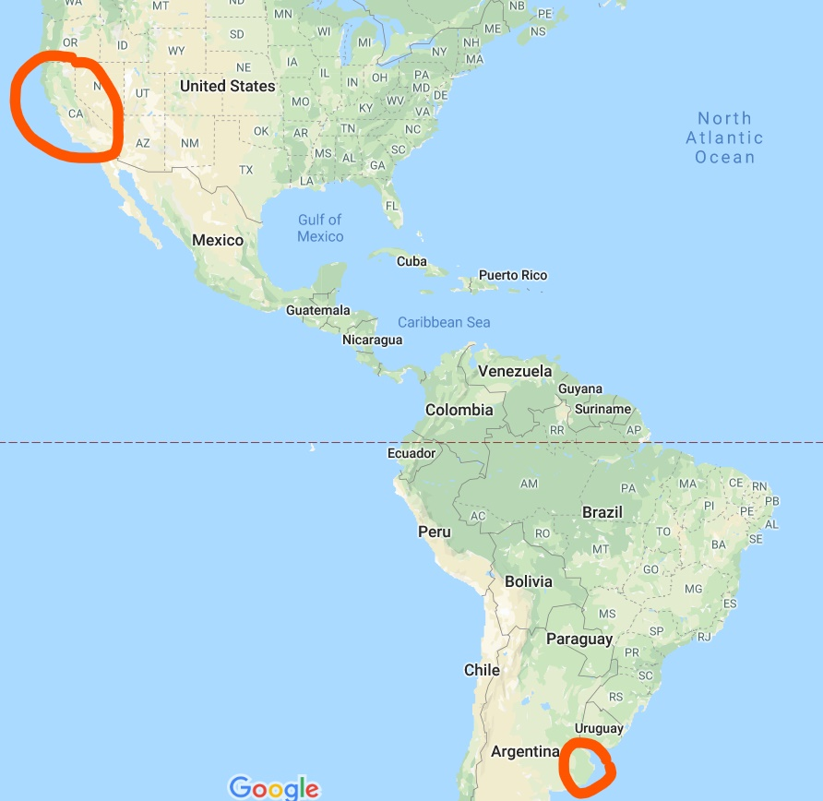

Challenge
Which route could I take that goes through the least amount of countries?
Which route could I take that goes through the most amount of countries?

