Race Across the World
Task 2
You are about to embark on a journey across two continents to Buenos Aires that may take many months to complete. So, what will you pack? Will you fill your backpack with essentials such as medicine and a water bottle or home comforts like photographs?
There’s limited space in your backpack so you can only pack 10 items! For each item, write a short explanation about why you have picked it and what you will use it for on your long journey.
Remember, you will be able to find accommodation on your route so you won’t need tents or sleeping bags. Food and drink will be available everywhere and it will weigh a lot in your backpack so it’s best to avoid bringing that too.
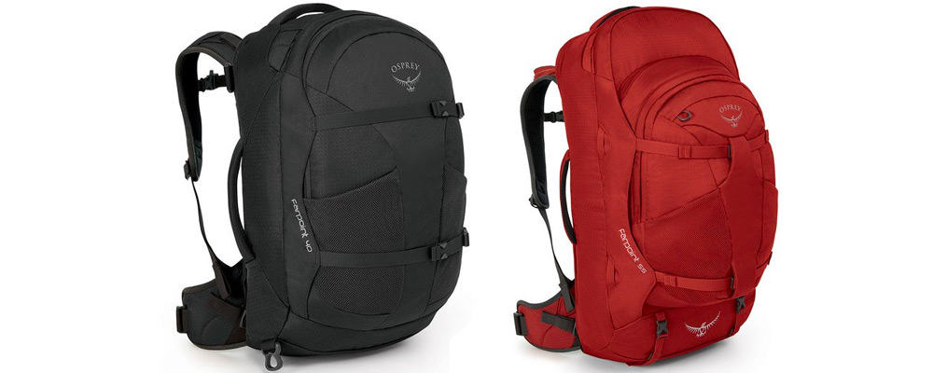
Example
Camera
A camera is an essential item to pack on a once in a lifetime journey such as this. No doubt I will visit many magnificent places such as the vast Amazon Rainforest and the ancient Mayan temples at Chichen Itza and will want to capture it all. In addition to this, I can send photographs to my family and friends so they can keep up to date with my adventure.

