

**Get the reading habit.**

**It keeps your brain in shape.**

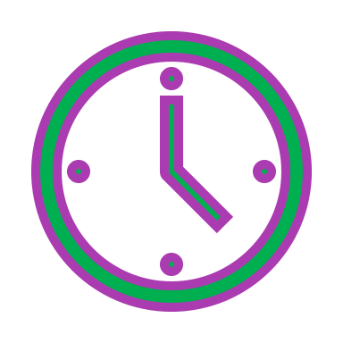 **Make a “reading time”**

Then you will remember to do it every day.

Maybe after you’ve got dressed or after your lunch.

Try to find a comfy place where you won’t be disturbed.

**Read the right level.**

Read the first page.

Hold up one finger for every word you get stuck on - five fingers and that book is too tricky for now.

**Re-read** a book you’ve read before.

Every time you re-visit a book you will discover things you missed last time.

**Be an actor.**

Read picture books to your younger brothers or sisters, if you have them, or film yourself reading for your cousins.

Put on voices and make it fun.

**Make a list**

List the books you’ve read (maybe on the back page of your writing book.) Give each book a mark out of ten and write a sentence about it.

When we go back to school you will be able to show your teacher how much you’ve read and have some recommendations for your friends.

** It’s all reading.**

Reading doesn’t have to be stories.

Recipes, websites, comics, song lyrics, non-fiction books … they’re all reading!

**The more you read the better you get.**

**Happy reading! **