Race Across the World
Task 3
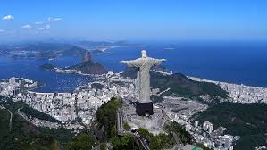
Throughout your journey from Los Angeles to Buenos Aires, you would have visited many countries. Your task is to research a country you will pass along the way. Will you choose Belize, Costa Rica or perhaps Ecuador? It’s completely up to you.
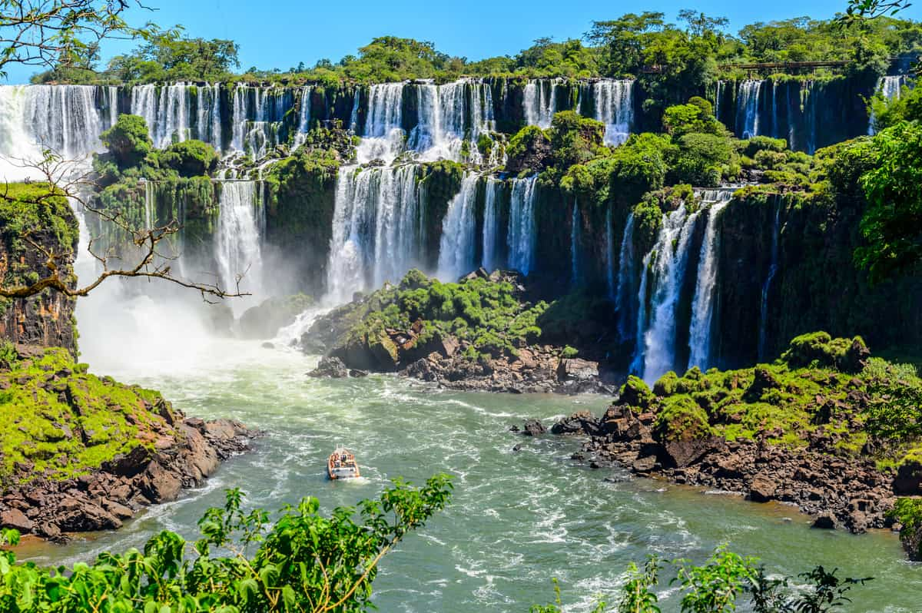
You will need to find out about:
- location
- population
- language spoken
- currency
- capital city
- climate
- culture
- food and popular dishes
- celebrations and festivals
- main attractions and landmarks

Once you have researched a country of your choice, you will need to present your information. You could choose: poster, leaflet, artwork, poem, song, travel guide or a PowerPoint presentation.

When you have finished, publish your work on the class blog. We would love to see it!

