Curriculum Overview
Nurture Inspire Achieve
At Holymead Primary School we want our pupils to achieve high quality outcomes, through a broad, balanced, inspiring (creative, fun and exciting) curriculum.
Our focus is on:
- Keeping children safe
- Good quality teaching focusing on skills and knowledge
- A well planned, coherent, varied and interesting curriculum
- High quality outcomes
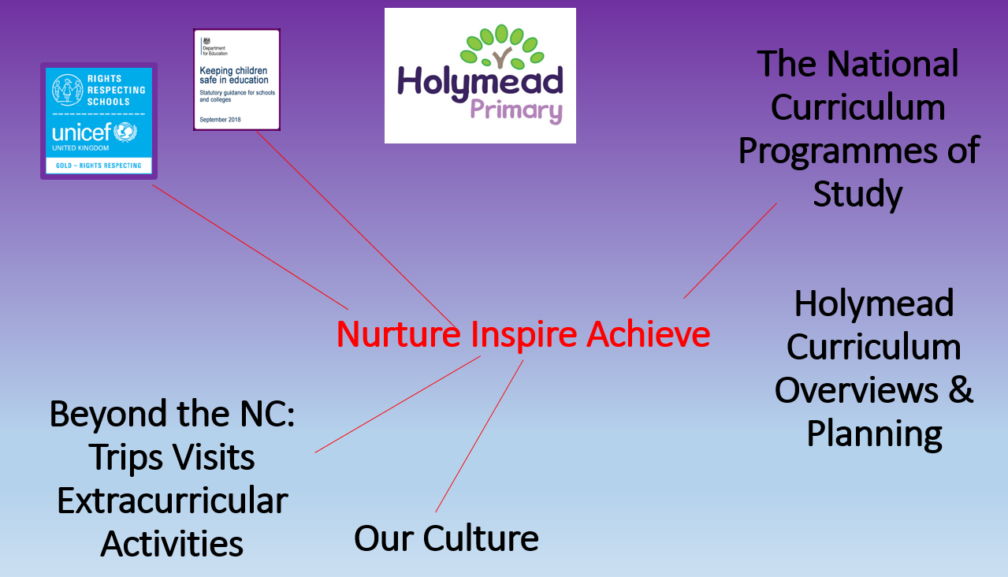

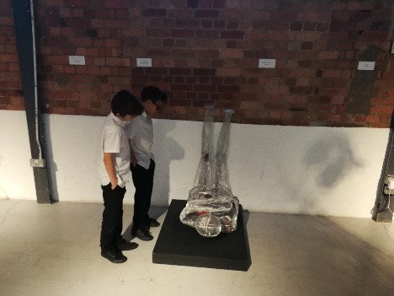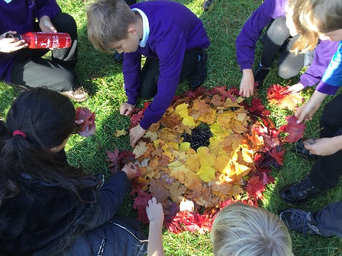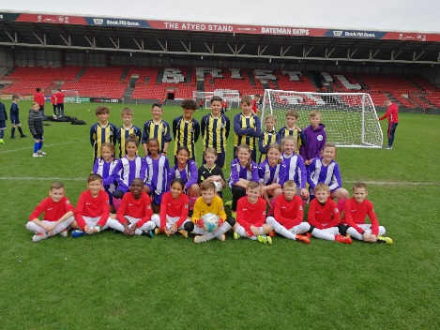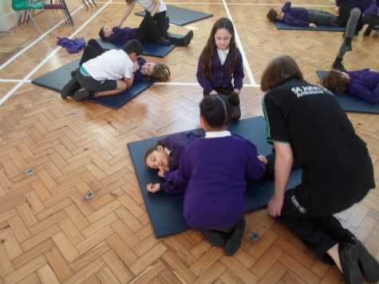
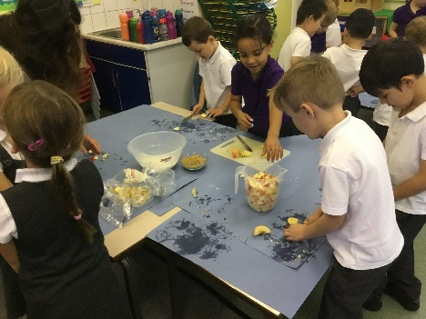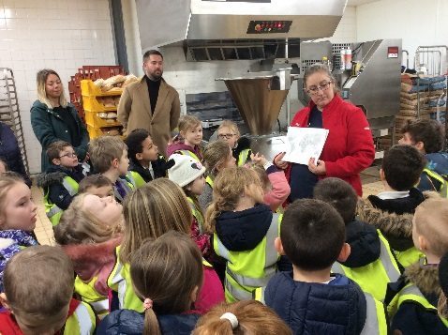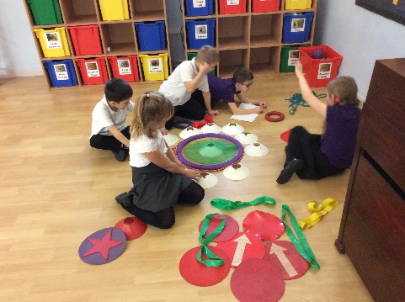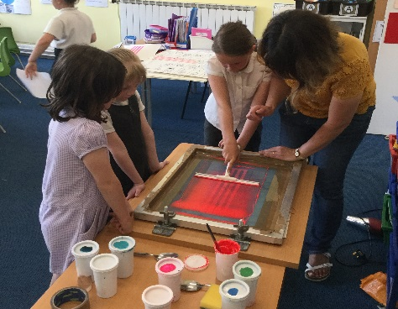
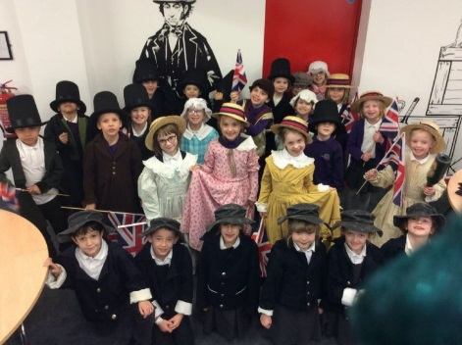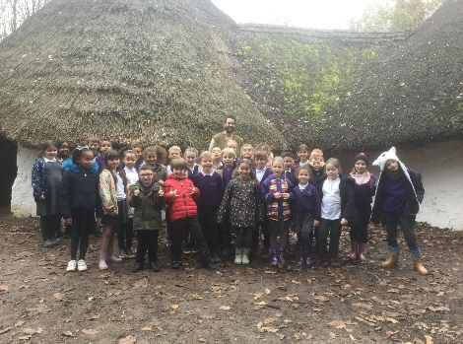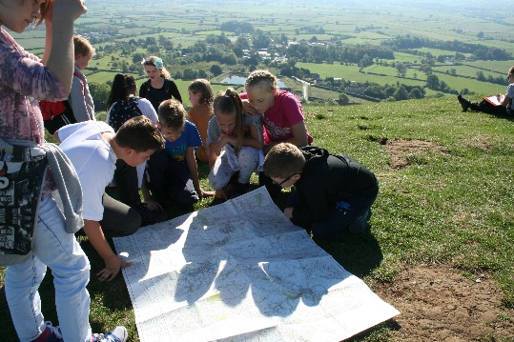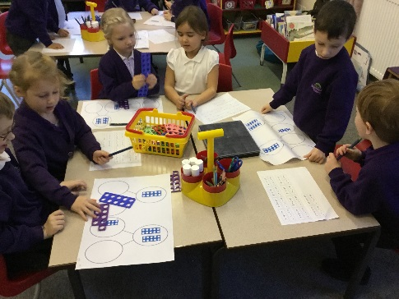
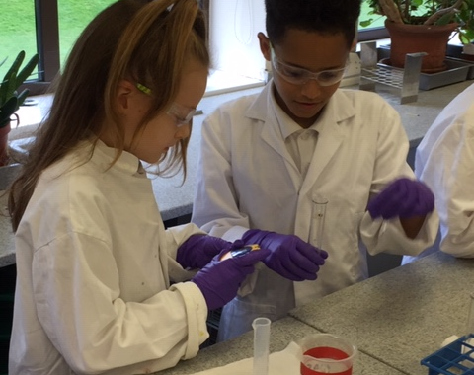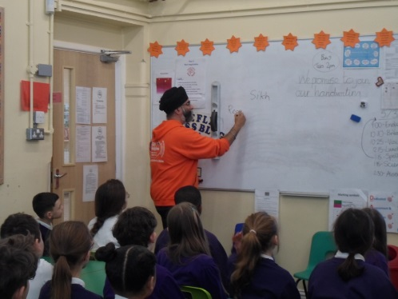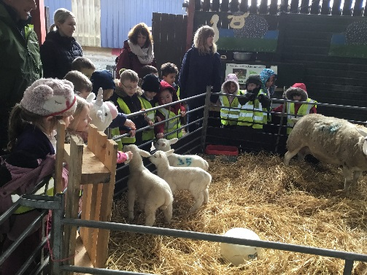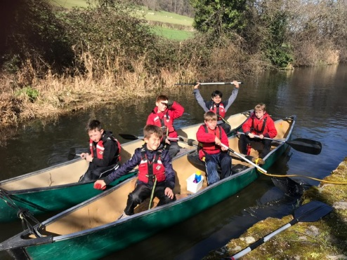
Art Curriculum Overview
Elements
Skills | Space (perspective) | Colour | Line | Pattern | Texture | Tone | Shape & Form
Artists: Study, evaluation and reproduction
 | Reception (YR) | Year 1 | Year 2 | Year 3 | Year 4 | Year 5 | Year 6
Unit 1: | Giuseppe  Arcimboldo | Vincent Van Gogh  Starry Night | Henri Matisse | Stone Age art | Aivazovsky  (Seascapes)  Nicola Bayley-illustrator | Amy O’Neill  Photography unit based on National Geographic Magazine | Andy  Goldsworthy
Unit 2: | Joan Miro | Piet Mondrian  Eric Carle  Wassily Kandinsky | Yvonne Coomber | Van Gogh | Rachel Drucker  (Wire Sculpture) | Andy Warhol | Frieda Kahlo
Unit 3: | Romero Britto | Anish Kapoor | Traditional Kenyan African Art | Gaudi | Henri Matisse | Banksy
Trips and Events
 | Paintworks Cluster Exhibition (biennially)  Christmas Art Designs  Aardman Animations Trails | Paintworks Cluster Exhibition (biennially)  Christmas Art Designs  Aardman Animations Trails | Paintworks Cluster Exhibition (biennially)  Christmas Art Designs  Aardman Animations Trails | Paintworks Cluster Exhibition (biennially)  Christmas Art Designs  Aardman Animations Trails | Paintworks Cluster Exhibition (biennially)  Christmas Art Designs  Aardman Animations Trails | Paintworks Cluster Exhibition (biennially)  Christmas Art Designs  Aardman Animations Trails | Paintworks Cluster Exhibition (biennially)  Christmas Art Designs  Aardman Animations Trails  Bristol Downs Trip creating Andy Goldsworthy Art

Computing Curriculum Overview
Elements
Programming  Unit 1 and 2 |  |  | Multimedia |  |  | E-Safety |  |  | ICT Skills
 | Reception (YR) | Year 1 |  | Year 2 | Year 3 |  | Year 4 | Year 5 |  | Year 6
Term 1/2 | Remote control toys  Programming toys-Bee bots  Ipads  Using pretend kitchen items  Sound buttons  Light boards  E-safety  What is technology?  Technology questionnaire for parents | Programming: (i)commands to make a device move (ii)multi step inputs |  | -Multimedia: (i) Stop motion animation app  -Music apps on ipad (linked to rhythm)  -Blogging skills | Programming: (i)Coding using Lego We Do (ii)creating a game using Scratch Junior |  | Programming: Coding to create repeating patterns and repetition using Kudo, Lego We Do and Romo | Programming: Design, write and debug programs |  | Programming: (i)Coding using Scratch to create games (ii)Coding using Scratch to investigate Shapes
Term 3/4 |  | Multimedia: (i) Stop motion animation (ii)Movie maker App |  | Kodable and Daisy the Dinosaur  Programming: Coding and multi-step input | Creating music using Scratch Junior  Databases: Using and Creating |  | Multimedia: Animation using Pivot Stick | Multimedia: Animation using i-Movie |  | Multimedia: Animation using Garage Band
Term 5/6 |  | Computing skills |  | Programming: Coding using Scratch Junior | Multimedia: Animation using a Green Screen |  | Multimedia: Animation using Pivot Stick | Multimedia: Animation using i-Movie |  | Multimedia: Animation using Garage Band

Cooking Curriculum Overview
Elements
Skills | Peeling & Grating | Mixing & Kneading | Knife skills: bridge, claw and spreading | How to read a recipe | Measuring ingredients | Using a heat source safely: boiling, simmering | Chopping (Including cross chop technique)
Cooking Curriculum Guidelines | Use the basic principles of a healthy and varied diet to prepare dishes. | Understand where food comes from. | Understand and apply the principles of a healthy and varied diet. | Prepare and cook a variety of predominantly savoury dishes using a range of cookery techniques. | Understand seasonality, and know where and how a variety of ingredients are grown, reared, caught and processed.
Artists: Study, evaluation and reproduction
 | Reception (YR) | Year 1 | Year 2 | Year 3 | Year 4 | Year 5 | Year 6
Term 1/2 | Bushcraft cooking  (Veg soup & flatbreads)  Christmas party cooking | Autumn Fruit crumble  (Berries/apples)  Christmas Party | Sour Dough Bread  Christmas Party | Carrot & coriander soup  With bread rolls  (Carrots) | Vegetable chow mein  (Carrots/courgettes) | Chickpea burgers & salad | Vegetable Cassoulet  (Seasonal Veg)
Term 3/4 | Savoury Gruffalo Crumble  (Potatoes/garlic/onions) | Samosa  (Potatoes/carrots/garlic) | Cheese/Broccoli muffins  (Broccoli) | Chocolate tart and sauce | Spring Pizza  (Onions, peppers, mushrooms) | Cheesecake & apple compote | Apple Pie  (Apples)
Term 5/6 | Feta Cheese parcels with herbs | Falafels & Salad  (Garlic/lettuce/cucumber) | Pirate fruit cups | Falafel & Tzatziki  (Coriander & Parsley) | Scones & Jam  (Strawberries/raspberries) | Macaroni Cheese | Jamaican Patties

Design Technology Curriculum Overview
Elements
Skills | Designing: Planning and communicating ideas |  | Making: Working with tools and equipment |  |  | Evaluating: Reflecting on process and product |  |  | Technical knowledge: Understanding materials and components.
 | Reception (YR) | Year 1 |  | Year 2 | Year 3 |  | Year 4 | Year 5 |  | Year 6
Term 1/2 |  | Sewing (The Queens Knickers by Nicholas Allan) |  | Textiles and sewing (Christmas decorations) | Shell structures  Data  Bronze/Iron Age homes |  | Design and build Roman Shields | Woodwork – Frame structures/ Christmas decorations
Term 3/4 |  | Mechanisms  Data  Slides and levers |  | Wheels and axels  Data  Cars | CAD - 2D Primary |  | Engineering: building bridges (Lego and K’nex) | Design and build Viking Helmets
Term 5/6 |  | Design and modelling (space junk) |  | Structures  Data  Bridges | Textiles  Data  Weather mobiles |  | CAD - 2D Primary | Textiles and sewing  Space keyrings
Trips and Events
 | Paintworks Cluster Exhibition (biennially) | Paintworks Cluster Exhibition (biennially) |  | Paintworks Cluster Exhibition (biennially)  SS Great Britain & Brunel | Paintworks Cluster Exhibition (biennially)  St Fagans |  | Paintworks Cluster Exhibition (biennially)  St Fagan’s Trip | Paintworks Cluster Exhibition (biennially) |  | Paintworks Cluster Exhibition (biennially)

English Curriculum Overview
Skills | Reading  Decoding and Comprehension | Handwriting and Presentation | Spelling | Grammar and Punctuation | Composition | Exploring Text Type and Genre | Editing
Writing Text Type and Genre (see KS2 appendices for more detail)
 | Reception (YR) | Year 1 | Year 2 | Year 3 | Year 4 | Year 5 | Year 6
Term 1 | Name writing  Pencil grip  Initial sounds  CVC words  Segmenting  Blending  What is a word  What is a sentence  Capital letters, full stops, finger spaces  Story maps  Non-fiction writing-fact books  Writing clues  Writing instructions  Writing letters  Rewriting stories  Recounts  Innovating stories | Books providing cc focus for PSHC RR.  Sequencing sentences to form a short narrative.  Character description. | Fiction  sequencing  Diary entry  Descriptions  Newspaper report  Rhyme  Story writing Poems  Non- Fiction  Non-chronological Report writing | Fiction  Diary entry  Character descriptions  Writing traditional tales | Character descriptions  Setting descriptions  Song writing  Diary entry  Narrative | Fiction - Journey  Persuasive Text  Diary Entry  Suspense/Dramatic story | Argument text  Diary  (ship’s log)  Instruction and explanation  Persuasive writing  Fiction writing (scene)
Term 2 |  | Sequencing sentences to form a narrative.  Descriptive writing  Non-fiction fact file  Poetry – Colour & Michael Rosen Rap  Descriptive writing  Poetry | Non-Fiction  Recipes  Instructions  Chronological report writing  Fiction  Characters Description  Story writing | Non-Fiction – The Emperor’s Egg  Newspapers  Persuasive writing  Non-chronological reports | Non-chronological report | AMND and UP  Play script  Newspaper Report  Change of mood piece | Informal letter  Recount  Fiction  Diary  Fiction  Direct speech  Play scripts  Explanations
Term 3 |  | Fiction  Traditional tale writing  Character description  Setting description  Story sequencing and re-writing.  NF  Non chronological report writing of trip  Instruction writing | Fiction  Character  Story writing  Description.  Poems  Non- fiction  Non-chronological report writing. | Fiction – Nim’s Island  Descriptive writing techniques  Note taking & fact files  Instruction writing | Diary entry  Newspaper report  Character descriptions  Non-chronological report  Poem | Beowulf  Myth and Legends  Persuasive Advert  Adventure Story  Biography | Formal letters  Non chon. Reports  Persuasive (adverts)  Informal letters  Romance fiction  Persuasion – WW2
Term 4 |  | Character description  Letter writing  Information poster  Labelling  Report writing  Re-write of story | Authors study  Book reviews  Story writing  Poems  Factual writing  Brunel | Fiction – Spiderwick  Character investigations& descriptions  Persuasive letters  Film reviews | Character description  Diary entry  Newspaper report  Narrative | A River Sea  Formal and explanation writing (letter)  Non-chronological Report  Information Text | Persuasion/ explanation  Suspense writing  Diary writing  Creating tension
Term 5 |  | Non chronological report  Non Fiction writing  instructions | Fiction  Character  Description  Historical writing  Letters  Persuasion  Diary entry | Non-fiction  Note taking & documentary scripts | Recipe / instructions  Narrative  Character description  Setting description | Warhorse  Story with historical setting  Story in the style of a significant author  Recount | Character description  Character perspective  Inference and fact retrieval  Symbolism in creative writing
Term 6 |  | Re- write of story  Persuasion  Writing  Book review  Scene description  Character description  NF non chronological report | Non- chronological report  Instructions  Story invention  Description | Fiction – Iron Man | Narrative  Menu  Playscript  Character description  Newspaper article | Harry Potter  Story set in an imaginary world | Scripts  Creative writing  Play scripts  Motivational speeches
Book Study
Term 1/2 | Topic-All about me  - This is our house  - Clever sticks  - Dentist non fiction book  - Friendship big books-e.g. Honesty  Topic-People who help us  - Story-The Bad Bread Adventure  - Non-fiction books about Firefighters, Doctors, vets and Police officers  - The birthday cake mistake (E book)  - Happy families series | - The Smartest Giant In Town  - Clever Sticks  - Peace at Last  - Not Now Bernard  - Where the Wild Thing Are  - Our House  - Ahh Spider  - Poetry: Michael Rosen Colours | - The snail and the whale  - The storm whale  - The Highway Rat  - Pumpkin soup  - Instructions and recipes  - The story of Guy Fawkes  - The Bear and the Piano  - Lost in the toy museum  - Lost in the toy museum at Christmas | Stone Age Boy by Satoshi Kitamura  A Sailing Boat by Quentinn Blake  The Emperor’s Egg by Martin Jenkins | The Mousehole Cat by Antonia Barber  The BFG by Roald Dahl | Journey by Aaron Becker  A Midsummer Night’s Dream by William Shakespeare (retold by Helen Street) | Kensuke’s Kingdom By Michael Morpurgo
Term 3/4 | Topic-Space  - Story -Whatever Next-Jilly Murphy  - Aliens love underpants  - Non-fiction books related to space  - Man on the moon  - But Martin  - Zoom rocket zoom  - How to catch a star  Topic-Animals  - Story- Dear Zoo  - Handa’s Surprise  - Animal non-fiction book | - Little Red Hen  - Traditional Tales- Stone soup  - Jack and the Bean Stalk  - Jim and the bean Stalk  - The Queen Knickers  - Poetry- Brown bear | - Stellaluna  - Lost in the Toy museum  - Author study Anthony Brown  - Gorilla  - Tunnel | Nim’s Island  By Wendy Orr  The Spiderwick Chronicles  By Holly Black & Tony DiTerlizzi | The Lost Thing by Shaun Tan  Poetry by Michael Rosen  Thieves of Ostia by Caroline Lawrence | Beowulf by Michael Morpurgo  Journey to the River Sea by Eva Ibbotson | Macbeth  By William Shakespeare
Term 5/6 | Topic-Traditional tales  - The three little pigs  - Three Billy goats gruff  - Goldilocks and the three bears  - Gingerbread man  Topic-If you go down to the woods  - Story-The Gruffalo  - Non fiction about bugs and trees  - The Gruffalo’s child  - Percy the Park Keeper  - Other Julia Donaldson books | - The perfect present  - The Tiny Seed  - The First Moon Landing  - Traction man  - Poetry |  | The Iron Man  By Ted Hughes | Inside the Villains by Clotilde Perrin  Firework Maker’s Daughter by Phillip Pullman  The Clown by Quentin Blake  Electricity | War Horse  By Michael Morpurgo  Man on the Moon by Simon Bartram | Skellig/ Hamlet  By David Almond
Trips and Events
 | - Christmas Production | - Christmas Productions KS1  - Pantomime Y1-4  - In School Theatre Visit T4 | - Christmas Productions KS1  - Pantomime Y1-4  - Christmas Production  - In School Theatre Visit T4 | - Spelling Bee  - Pantomime Y1-4  - In School Theatre Visit T4 | - Y4 Christmas Production  - Pantomime Y1-4  - In school theatre visit T4 | - Harry Potter World: Visit and Workshop  - Tobacco Factory Visit  - In School Theatre Visit T4 | - Spelling Bee  - Theatre Visit T4  - Term 2  - Harry Potter World: Visit and Workshop  - In School Theatre Visit T4

Geography Curriculum Overview
Elements
Skills | Locational Knowledge |  | Place Knowledge |  |  | Human and Physical Geography |  | Geographical skills and fieldwork
Artists: Study, evaluation and reproduction
 | Reception (YR) | Year 1 |  | Year 2 | Year 3 |  | Year 4 | Year 5 | Year 6
Term 1/2 | Knowledge and Understanding of the World | Seasons |  | Locations – countries, capitals, oceans, continents |  |  | Mapping  Human Impact, Ecology and Sustainability | Voyages of Discovery (Trade) | Comparing Glastonbury and Normandy
Term 3/4 |  | Move It |  | Map Makers – physical and human features  of places  Local Walk | Explorers  Spain |  |  | Amazon Rainforest
Term 5/6 |  | Map Skills  Our Local Area |  | Contrasting UK with non – European country (Kenya) | Weather |  | Local Area Study (Brislington) | Map Skills | Natural Hazards- Volcanoes
Trips and Events
 | Local park  Library  Farm  Autumn walk | Local area walk T5  Ashton Court Trip T6 |  | Tyntsefield  Tesco: where food comes from | Agricultural Show T3 |  | Folly Farm T2 |  | Glastonbury T1

History Curriculum Overview
Skills: | Chronology |  | Knowledge and Understanding |  | Interpretation |  | Enquiry |  | Organisation |  | Communication
 | Year R | Year 1 |  | Year 2 |  | Year 3 |  | Year 4 |  | Year 5 |  | Year 6
Term 1/2 | How I have changed.  (My personal history)  Treasure Box  Remembrance Day | Changes within living memory:  Toys |  | Significant event beyond living memory:  Guy Fawkes and the Gunpowder Plot |  | Chronological Unit:  Stone Age |  | Chronological Unit:  The Celts |  | Chronological Unit:  The Ancient Greeks |  | Chronological Unit:  Medieval Britain  (The Normans)
Term 3/4 | Firsts in space.  First Rocket.  First Animals  First Man | Comparing lives of significant individuals:  Queen Victoria and Queen Elizabeth II |  | Significant individual within locality:  Brunel |  | Chronological Unit:  Bronze and Iron Age |  | Chronological Unit:  The Romans |  | Chronological Unit:  Vikings and Saxons |  | History Beyond the chronology of 1066:  World War II
Term 5/6 | People who Help us-how clothes and uniforms have changed. | Significant event beyond living memory:  The first man on the moon |  | Comparing individuals who have national or international achievement:  Florence Nightingale |  | Ancient World:  Egyptians |  | Non-European History:  The Maya Civilisation |  | Local History:  Bristol
Trips and Events: | Tyntesfield (T6)  How people lived | T1 Bring to school an old and new toy. |  | SS Great Britain Term 3  STEM Bridge Building Workshop Term 4 |  | St Fagans (Term 1)  Caerleon Term 4  Egyptian Day  (Term 6) |  | Roman Day Term 4  Caerleon Trip Term 4 |  |  |  | World War 2 Day  (Term 3)

Maths Curriculum Overview
National Curriculum Strands
Fluency  - become fluent in the fundamentals of mathematics, including through varied and frequent practice with increasingly complex problems over time, so that pupils develop conceptual understanding and the ability to recall and apply knowledge rapidly and accurately |  |  | Reasoning  - reason mathematically by following a line of enquiry, conjecturing relationships and generalisations, and developing an argument, justification or proof using mathematical language |  | Problem Solving  - can solve problems by applying their mathematics to a variety of routine and non-routine problems with increasing sophistication, including breaking down problems into a series of simpler steps and persevering in seeking solutions
Topics in the National Curriculum (all year groups) – see skills sheets & maths across the curriculum
Number – number and place value | Number – addition and subtraction | Number – multiplication and division | Number – fractions (including percentages and decimals from Y5) | Measurement | Geometry – properties of shapes | Geometry – position and direction | Statistics
Additional topics in Y5: Percentages and Decimals |  |  |  | Additional Topics in Y6: Ratio and Proportion, Algebra
Multiplication Tables Expectations
YR | Y1 | Y2 | Y3 | Y4 | Y5 | Y6
Pupils solve problems, including doubling, halving and sharing. | Counting in 2,5,10 | Recall and use multiplication and division facts for the 2, 5 and 10 multiplication tables, and counting in 3s. | Recall and use multiplication and division facts for the 3, 4 and 8 multiplication tables | Recall multiplication and division facts for multiplication tables up to 12 × 12  [Recall and use 6,7,9,12 multiplication tables] | Pupils use and understand the terms factor, multiple and prime, square and cube numbers. | Pupils continue to use all the multiplication tables to calculate mathematical statements in order to maintain their fluency.
Events
Problem Solver of the Term  Number Day | Problem Solver of the Term  Number Day | Problem Solver of the Term  Number Day  TT Rockstars Contest | Problem Solver of the Term  Number Day  TT Rockstars Contest | Problem Solver of the Term  Number Day  TT Rockstars Contest  Year 4 Maths Workshop with Cluster | Problem Solver of the Term  Number Day  TT Rockstars Contest  Year 5 Bristol Grammar School Maths Challenge | Problem Solver of the Term  Number Day  TT Rockstars Contest  Year 6 Red Maids’ High School Maths Challenge event

Music Curriculum Overview
Elements
Skills | Rhythm beat  Repetition evaluation of music and feelings | Pulse, rhythm, pitch, beat, composition | pulse, rhythm, pitch singing and playing instruments | Note reading, Pitch  tone | Pitch, performance, reading music notation | sing, play, improvise and compose with this song, | Improvise, appraise, tone, pitch, volume, structure of songs
Songs and topic
 | Reception (YR) | Year 1 | Year 2 | Year 3 | Year 4 | Year 5 | Year 6
Term 1 and 2 | Learn to sing nursery rhymes and action songs:  5 Little ducks | Hey You!  As well as learning to sing, play, improvise and compose with this song, children will listen and appraise other old school hip hop tunes | Hands, Feet, Heart.  As well as learning to sing, play, improvise and compose with this song, South African music. | Recorders note b | Mama Mia – learning about pop songs – structure and playing instruments with song | Living on a Prayer  Three Note Bossa and Five Note Swing  Improvisation | Bacharach Anorak and Meet The Blues.
Term 3 and 4 | Baa Baa Black Sheep  Incy Wincy Spider  Wheels on the Bus  Learning and performance | Blues, Baroque, Latin, Bhangra, Folk and Funk.  In The Groove. | I Wanna Play In A Band – evaluating rock songs  Zoo time – mixing genres of music | Recorders notes b and a | Learning about the different parts of an orchestra  Practice for BSO concert | Make you feel my love – pop ballads  Fresh Prince – learning to rap | Benjamin Britten’s Friday Afternoons: A New Year Carol.
Term 5 and 6 | - Listening and appraising Funk music. Playing percussion along in a class with funk music. | - Listen and Appraise Classical music  - Singing  - Play instruments within the song  - Improvisation using voices and instruments | Friendship songs – composition  Classical music appraisal | Recorder notes b, a, g and c | BlackBird – Beetles – playing glockenspiels and recorders along with Song | Learning to appraise classical music  Music games | History of Music and the beginnings of the Language of Music.
Trips and Events
 | Christmas Concert  Christmas Production  Chinese New Year Music workshop | Christmas Concert  Christmas Production | Christmas Concert  Christmas Production | Recorder concert | Colston Hall  Year 4 Christmas production  Bournemouth Symphony Orchestra visit  Christmas Concert  Summer Concert  Choir visit St Anne’s | Christmas Concert  Summer Concert  Choir visit St Anne’s | St Paul’s Carnival  Christmas Concert  Summer Concert  Year 6 Summer Production  Choir visit – St Anne’s

PSHC Curriculum Overview
Elements
UNICEF Rights Respecting School  Rights & Responsibilities  - Ongoing and fed throughout whole school ethos and curriculum |  | British Values  - Discrete lessons taught |  |  | Jigsaw Scheme of Work |  |  | Sustainable Development Goals  - Global lessons termly  - SDGS posters  - Global focus homework
 | Term 1 |  | Term 2 | Term 3 |  | Term 4 | Term 5 |  | Term 6
JIGSAW  Whole School Year R to Year 6 | Being Me In My World |  | Celebrating Difference | Dreams and Goals |  | Healthy Me | Relationships |  | Changing Me
Year R | Create RRS charter. To talk about feelings and emotions. To learn how to be a good friend. |  | What makes us special. Sharing our achievements. How our homes are different? Looking at who is in my family and what other families look like. | Learning how to achieve our goals. Perseverance. Challenging ourselves, setting goals. Positive attitudes toward are work and our achievements. |  | How to stay heathy. Talking about different types of healthy food. Learning about the importance of sleep and keeping clean. | How to resolve conflicts with others. What is bullying? Comparing kind words and unkind words. Understanding how to help themselves and others when they are feeling upset or hurt. |  | Thinking about how we change as we grow. Learn to express how they feel when things change. Label different body parts. Lifecycles.
Year 1 | Create class RRS charters |  | I understand how being different can make me feel special / unique | Success and celebrating new challenges |  | Why my body is amazing and how to keep it healthy | Why I appreciate someone special to me. How I feel about them. |  | Identify the parts of the body that make boys  different to girls. Moving on  and can use the
Year 2 | Create class RRS charters |  | I can tell you why I value difference | Working cooperatively as part of a group |  | I can make some healthy snacks and explain why they are good for me | Things that cause conflict between me and my friends |  | RSE  Differences between boys and girls, use the correct names for parts of the body. Moving on
Year 3 | Create class RRS charters  Rewards and consequences |  | I can give and receive compliments | My learning process and how to improve next time |  | Keeping myself safe. Identify things, people and places. | Different roles and relationships within the family. |  | RSE  (Naming body parts scientifically)
Year 4 | Create class RRS charters  (Decision making) |  | Explain why it is good to accept people the way they are | Set goals and plans. Build resilience |  | Identifying feeling of people putting me under pressure | Different points of view on animals rights issue |  | RSE  Body changes / Menstruation/ moving on
Year 5 | Create class RRS charters |  | Explain the difference between direct and indirect bullying | Describe the dreams and goals of a young person from a different culture |  | Describe important roles that food provides. Mental health / body image | E-safety – how I can use technology safely to communicate with friends |  | RSE  how boys’ and girls’ bodies change during  puberty/ moving on
Year 6 | Create class RRS charters |  | Explain ways  in which difference  can be a source of  conflict or a cause  for celebration | Describe some ways in which I can work with other people to help make the world a better place I can identify |  | Evaluate when alcohol  is being used responsibly, antisocially or being  misused | I can recognise when others are trying to gain control. Standing up for myself |  | RSE  Describe how a baby  develops from conception and how it is born / body image. Moving on

Events, Trips and Visits
 | Peer mediator applications and training  New Y3 RAG applications  YR New baby visitor | Anti – Bullying Week  Aspiration Day fundraising  Fire fighter visit  YR visitors; police dogs, ambulance, dentist | Sikh visitor Y5  Forum meeting KS2 John Wesley visitor T3 | Y6 Camp  Eco Bricks  BSO Y4 T4  St John’s ambulance First Aid Training  Democracy Day  Year 6 Play Leaders (KS1 site) | Forum meeting KS2/1  Walk to school week  SDGS poster competition  Heritage Day | Year 4 Camp T6  Y6/7 Transition Days  Sports Days  Lifeskills trip

RE Curriculum Overview
Elements
Skills  These skills go across all year groups. Please see each individual unit for the skills that are covered. |  | Beliefs, teachings and sources | Practices and ways of life | Forms of expressing meaning | Identity, diversity and belonging | Meaning, purpose and truth | Values and commitments
Artists: Study, evaluation and reproduction
 | Reception (YR) | Year 1 | Year 2 | Year 3 | Year 4 | Year 5 | Year 6
Terms 1/2 | Who are we?  - Christianity  - Islam | Why are some places special?  - Hinduism | Where do we belong?  - Judaism | What is important to me?  - Christianity  - Judaism | What does it mean to belong to a religion?  - Judaism | Why do religious books and teachings matter?  - Christianity  - Islam | What does it mean to belong to a religion?  - Christianity
Terms 3/4 | Why is Jesus important?  - Christianity | Why is our world special?  - Christianity  - Hinduism | Why are some stories special?  - Christianity  - Islam  - Judaism | What can we learn from the life and teaching of Jesus?  - Christianity | How should we live and who can inspire us?  - Judaism  - Sikhism | Why are some journeys and places special?  - Christianity  - Islam | What does it mean to belong to a religion?  - Islam
Terms 5/6 | Why are some times special?  - Christianity  - Judaism | How do we celebrate our journey through life?  - Christianity  - Hinduism  - Islam  - Judaism | How should we live our lives?  - Judaism | How do people express their beliefs, identity and experience?  - Christianity  - Hinduism | What does it mean to belong to a religion?  - Hinduism | How do we make moral choices?  - Christianity  - Hinduism | What do people believe about life?  - Christianity  - Islam
Trips and Events
 | Whole school RE art competition  Whole School Christmas Service | Whole school RE art competition  Whole School Christmas Service  St Luke’s Church visit  Barnabas RE Day | Whole school RE art competition  Whole School Christmas Service  Church visit  Barnabas RE Day | Whole school RE art competition  Whole School Christmas Service  Visit to Hindu Temple | Whole school RE art competition  Whole School Christmas Service  Visitor from New Rooms (John Wesley) | Whole school RE art competition  Whole School Christmas Service  Sikh visitor and workshop | Whole school RE art competition  Whole School Christmas Service  Visit to Arnos Vale

Science Curriculum Overview
Working Scientifically
Skills | Understanding the World (The World), Characteristics of Learning (Creative & Critical Thinking) | Look, Book, Sort, Test |  | Observing over time, Identifying, classifying & grouping, Pattern seeking, Comparative & fair testing, Researching using secondary sources
Units
 | Reception (YR) | Year 1 | Year 2 | Year 3 | Year 4 | Year 5 | Year 6
Term 1 | Our Body  (inc. healthy eating) | Seasons  (describe) | Living Things  (living or dead & food chains) | Rocks  (physical properties & fossils) | Living Things and their Habitats (grouping, classification & environmental factors) | Forces  (gravity, mechanisms, naming forces) | Evolution and Inheritance  (adaptation, inheriting characteristics)
Term 2 | Materials  (reflective & waterproof) | Materials  (name, group & describe) | Animals (Including Humans)  (how humans survive & live) | Animals (Including Humans)  (skeletons, muscle & nutrition) | Electricity  (circuits, conductors & insulators) | Properties and Changes of Materials (comparing materials, reversible & irreversible changes) | Animals including Humans (circulatory system, impact of lifestyle)
Term 3 | Space (light and dark) & Ice (solid, liquids, gases & melting) | Animals (Including Humans)  (types of animals & human body parts) |  | Plants  (function of parts of plants and life cycle) |  |  | Light  (how light travels)
Term 4 | Animals  (characteristics & habitats) |  | Materials  (suitability of materials) |  | Sound  (vibrations, pitch & volume) | Electricity  (symbols, changing circuits) | Living Things and their Habitats (classification)
Term 5 | Chicks  (lifecycles inc. butterfly, chickens, frog) | Plants  (types of plants & basic structure) | Plants  (what they need & how they grow) | Light  (vision, reflections & shadows) | Animals (Including Humans) (digestive system, teeth & food chains) | Living things and their Habitats (life cycles & reproduction in animals & plants)
Term 6 | Minibeasts |  | Habitats  (suitability of habitats) | Forces and Magnets (repel & attract, movement) | States of Matter (solids, liquids & gases and changes) | Earth and Space  (day/night, relationship of sun, moon & earth) | Animals (Including Humans) (changes in humans)
Trips and Events
 | Science Days (Space Dome & rockets)  Chew Valley Farm Trip  Chicken Eggs  Tyntesfield Trip | Science Days  Court Farm Trip  Hedgehog Visitor  Ashton Court Trip  Local Nature Walk | Science Day (electricity, magnets & chemical reactions (volcanos))  STEM Bridge Workshop  Visit to SS Great Britain  RSPB Workshop | Science Days  Little Zoo Visit  North Somerset Agricultural Show | Science Days  Infant Garden  Folly Farm Visit  Chem Labs Visit | Science Days | Science Days

Holymead Primary School
Clubs and After School Activities Overview
 | Term 1 | Term 2 | Term 3 | Term 4 | Term 5 | Term 6
Reception | Zumba  Ukulele | Zumba  Ukulele | Zumba  Ukulele | Zumba  Ukulele  Mad Science | Zumba  Ukulele | Gardening  Ukulele
Year 1 | Zumba  Ukulele | Zumba  Ukulele | Zumba  Ukulele | Zumba  Ukulele  Mad Science | Zumba  Ukulele | Gardening  Ukulele
Year 2 | Zumba  Ukulele | Zumba  Ukulele | Zumba  Gardening  Woodwork  Wellbeing  Animal Club  Cookery  Construction  Reading Cafe  Ukulele | Zumba  Gardening  Woodwork  Wellbeing  Animal Club  Cookery  Ukulele  Mad Science | Zumba  Gardening  Ukulele | Gardening  Ukulele
Year 3 | KS2 Football Club  KS2 Multisports  Cricket Club  Choir  Drama Club  Go Sketch (Art) Club  Zumba | KS2 Football Club  KS2 Multisports  Cricket Club  Choir  Drama Club  Go Sketch (Art) Club  Zumba | KS2 Football Club  KS2 Multisports  Cricket Club  Choir  Drama Club  Go Sketch (Art) Club  Zumba | KS2 Football Club  KS2 Multisports  Cricket Club  Choir  Drama Club  Go Sketch (Art) Club  Zumba  Mad Science | KS2 Football Club  KS2 Multisports  Cricket Club  Choir  Drama Club  Go Sketch (Art) Club  Zumba  Swimming Club | KS2 Football Club  KS2 Multisports  Cricket Club  Choir  Drama Club  Go Sketch (Art) Club  Zumba  Swimming Club
Year 4 | KS2 Football Club  KS2 Multisports  Swimming Club  Cricket Club  Choir  Drama Club  Go Sketch (Art) Club  Zumba  Music Lessons (Drums Keyboards Guitars Woodwind)  Recorder Club | KS2 Football Club  KS2 Multisports  Swimming Club  Cricket Club  Choir  Drama Club  Go Sketch (Art) Club  Zumba  Music Lessons (Drums Keyboards Guitars Woodwind)  Recorder Club | KS2 Football Club  KS2 Multisports  Swimming Club  Cricket Club  Choir  Drama Club  Go Sketch (Art) Club  Zumba  Music Lessons (Drums Keyboards Guitars Woodwind)  Recorder Club | KS2 Football Club  KS2 Multisports  Swimming Club  Cricket Club  Choir  Drama Club  Go Sketch (Art) Club  Zumba  Music Lessons (Drums Keyboards Guitars Woodwind)  Recorder Club  Mad Science | KS2 Football Club  KS2 Multisports  Swimming Club  Cricket Club  Choir  Drama Club  Go Sketch (Art) Club  Zumba  Music Lessons (Drums Keyboards Guitars Woodwind)  Recorder Club | KS2 Football Club  KS2 Multisports  Swimming Club  Cricket Club  Choir  Drama Club  Go Sketch (Art) Club  Zumba  Music Lessons (Drums Keyboards Guitars Woodwind)  Recorder Club
Year 5  Year 5 (continued) | Boys’ Football Team Training  Girls’ Football Team Training  KS2 Football Club  KS2 Multisports  Cricket Club  Choir  Drama Club  Go Sketch (Art) Club  Zumba  Music Lessons (Drums Keyboards Guitars Woodwind)  Recorder Club | Boys’ Football Team Training  Girls’ Football Team Training  KS2 Football Club  KS2 Multisports  Cricket Club  Choir  Drama Club  Go Sketch (Art) Club  Zumba  Music Lessons (Drums Keyboards Guitars Woodwind)  Recorder Club  Music Lessons (Drums Keyboards Guitars Woodwind)  Recorder Club | KS2 Football Club  KS2 Multisports  Swimming Club  Cricket Club  Choir  Drama Club  Go Sketch (Art) Club  Zumba  Music Lessons (Drums Keyboards Guitars Woodwind)  Recorder Club | Reading Cafe  Girls’ Dodgeball Club  KS2 Football Club  KS2 Multisports  Swimming Club  Cricket Club  Choir  Drama Club  Go Sketch (Art) Club  Zumba  Music Lessons (Drums Keyboards Guitars Woodwind)  Recorder Club | Reading Cafe  KS2 Football Club  KS2 Multisports  Swimming Club  Cricket Club  Choir  Drama Club  Go Sketch (Art) Club  Zumba  Music Lessons (Drums Keyboards Guitars Woodwind)  Recorder Club | KS2 Football Club  KS2 Multisports  Swimming Club  Cricket Club  Choir  Drama Club  Go Sketch (Art) Club  Zumba  Music Lessons (Drums Keyboards Guitars Woodwind)  Recorder Club
Year 6 | Boys’ Football Team Training  Girls’ Football Team Training  KS2 Football Club  KS2 Multisports  Swimming Club  Cricket Club  Choir  Drama Club  Netball Club  Go Sketch (Art) Club  Zumba  Music Lessons (Drums Keyboards Guitars Woodwind)  Recorder Club | Boys’ Football Team Training  Girls’ Football Team Training  KS2 Football Club  KS2 Multisports  Swimming Club  Cricket Club  Choir  Drama Club  Netball Club  Go Sketch (Art) Club  Zumba  Music Lessons (Drums Keyboards Guitars Woodwind)  Recorder Club | Boys’ Football Team Training  Girls’ Football Team Training  KS2 Football Club  KS2 Multisports  Swimming Club  Cricket Club  Choir  Drama Club  Netball Club  Go Sketch (Art) Club  Zumba  Maths Club  Music Lessons (Drums Keyboards Guitars Woodwind)  Recorder Club | Boys’ Football Team Training  Girls’ Football Team Training  KS2 Football Club  KS2 Multisports  Swimming Club  Cricket Club  Choir  Drama Club  Netball Club  Go Sketch (Art) Club  Zumba  Maths Club  Music Lessons (Drums Keyboards Guitars Woodwind)  Recorder Club | Boys’ Football Team Training  Girls’ Football Team Training  KS2 Football Club  KS2 Multisports  Swimming Club  Cricket Club  Choir  Drama Club  Netball Club  Go Sketch (Art) Club  Zumba  Music Lessons (Drums Keyboards Guitars Woodwind)  Recorder Club | Boys’ Football Team Training  Girls’ Football Team Training  KS2 Football Club  KS2 Multisports  Swimming Club  Cricket Club  Choir  Drama Club  Netball Club  Go Sketch (Art) Club  Zumba  Music Lessons (Drums Keyboards Guitars Woodwind)  Recorder Club

Holymead Primary School
Educational Trips and Visits Overview
 | Term 1 | Term 2 | Term 3 | Term 4 | Term 5 | Term 6
Reception | Walk to Victory park-Autumn walk  Baby to visit | Police dogs  Ambulance  Dentist | Space dome  Chinese new Year music workshop | Chew Valley Farm | Living eggs  Story drama workshop | Tynesfield  Walk to the library
Year 1 |  | Pantomime in school (English)  St Luke’s Church Visit (RE)  Hedgehog visitor (Science) |  | The Hobbit theatre (English)  Farm visit (Science) | Local Brislington walk (Geography)  Firemen visit (PSHC) | Ashton Court trip (Geography/Science)
Year 2 | RSPB Habitat workshop (science)  Walk to Tesco – where does our food come from? (Geography/PSHC) | Pantomime in school (English)  St Luke’s Church Visit (RE) |  | The Hobbit theatre (English)  SS Great Britain (History)  STEM Bridge Building Workshop (science, DT & history) | Firefighters Workshop (PSHC)  Asda Planting Workshop (science) | Tyntesfield (Science)
Year 3 |  | Pantomime in school (English)  St Fagans (History/DT)  Little Zoo visit (Science) |  | The Hobbit theatre (English) | Hindu Temple visit (RE) | Agricultural Show (Geography/Science)
Year 4 | Infant garden (Science) | Pantomime in school (English)  Folly Farm (Science) | John Wesley visitor (RE) | The Hobbit theatre (English)  Caerleon (History)  Bournemouth Symphony Orchestra (Music) |  | Chem Labs visit (Science)  Residential Camp: PGL Brecon
Year 5 |  | Pantomime – Tobacco Factory (English) |  | The Hobbit theatre (English)  First Aid Courses (PSHC)  Sikh visitor (RE) | Mental Health visitor (PSHC) | Harry Potter Studios (English)
Year 6 | Art Trip to The downs (Andy Goldsworthy)  Glastonbury Tor, Highstreet and Abbey (Geography) | Pantomime – Tobacco Factory (English)  Paintwork Visit (Art) | Arnos Vale Cemetery (RE)  WW2 Day (History) | The Hobbit theatre (English)  Residential Camp: Red Ridge  Life Skills (PSHC) |  | Brean Leisure Park: End of Year 6 Celebration Trip

