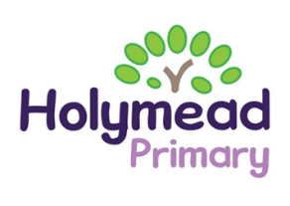
Key stage 2 comparative report
This information allows you to compare your child’s performance at the end of key stage 2 with the attainment of other year 6 pupils in our school and across England (based on provisional data).
Subject | Percentage of pupils achieving the expected standard: school | Percentage of pupils achieving the expected standard: nationally | Average scaled score: school | Average scaled score: nationally
English reading | 84% | 74% | 106.3 | 105
English grammar, punctuation and spelling | 81% | 72% | 107.2 | 105
Mathematics | 77% | 71% | 103.6 | 104
English writing (teacher assessment) | 71% | 69% | NA | NA
Science (teacher assessment) | 88% | 79% | NA | NA

Key stage 1 comparative report
This information allows you to compare your child’s performance at the end of key stage 1 with the attainment of other year 2 pupils in our school and across England (based on previous data).
Subject | Percentage of pupils achieving the expected standard: school | 2022 National figures not available  These are 2019 National figures
English reading (teacher assessment) | 72% | 75%
Mathematics (teacher assessment) | 64% | 69%
English writing (teacher assessment) | 76% | 76%
Science (teacher assessment) | 86% | 83%

